Ex. No. 2 | Working with HTML5 Form Elements
Date of Exercise | 21 / 07 / 2026
GitHub Host Link | https://git.karunya.edu/pages/URK24CS1216/web_tech_exp_1/

Aim

To design and implement an interactive Astrology Consultation Form using various HTML5 form elements and input controls, and to demonstrate the built-in browser validation features for collecting user information efficiently.

Description
HTML5 provides several advanced form elements and input types that simplify web form development and improve user experience. These elements offer built-in validation, better input handling, and enhanced usability without requiring JavaScript for basic validation.

In this experiment, an Astrology Consultation Form is developed using different HTML5 form controls such as text boxes, email fields, password fields, radio buttons, checkboxes, date picker, number input, dropdown list, textarea, color picker, file upload, range slider, and submit/reset buttons.

The form allows users to enter their personal details, choose astrology services, select their zodiac sign, upload a birth certificate, choose a lucky color, and submit their astrology-related queries.
The following HTML5 concepts are demonstrated:

- HTML5 <form> element
- Text input (type="text")
- Email validation (type="email")
- Password field (type="password")
- Number input (type="number")
- Date picker (type="date")
- Radio buttons
- Checkboxes
- Drop-down list (<select>)
- Text area (<textarea>)
- Color picker (type="color")
- File upload (type="file")
- Range slider (type="range")
- HTML5 validation attributes:
○ required
○ placeholder

○ min
○ max
○ pattern

These HTML5 features improve data accuracy, reduce user errors, and provide a better user
experience.

Procedure:
1. Open Visual Studio Code.
2. Create a new folder named HTML5_Form_Elements.
3. Create a new file named index.html.
4. Write the HTML5 document structure.
5. Create a Student Registration Form using the <form> element.
6. Add labels and text fields for student information.
7. Insert various HTML5 input controls such as email, password, number, date, radio buttons, checkboxes, dropdown, textarea, color picker, file upload, and range slider.
8. Apply HTML5 validation using required, min, max, and pattern attributes.
9. Add Submit and Reset buttons.
10. Save the file.
11. Open the file using Live Server or any web browser.
12. Test different inputs and verify browser validation messages.
13. Capture the output screenshot.

Program

<!DOCTYPE html>

<html>

<head>

<title>Astrology Consultation Form</title>

<style>

body {

background-color: #f3e8ff;

font-family: Arial, sans-serif; }

h2 {

text-align: center;

color: darkblue;

}

form {

width: 500px;

margin: auto;

background-color: white;

padding: 20px;

border: 2px solid gray;

}

label {

font-weight: bold;

}

input,

select,

textarea {

width: 100%;

padding: 8px;

margin-top: 5px;

margin-bottom: 15px; }

input[type=radio],

input[type=checkbox],

input[type=color],

input[type=range]

{

width: auto;

}

input[type=submit],

input[type=reset] {

width: auto;

padding: 10px 20px;

background-color: darkblue;

color: white;

border: none;

cursor: pointer;

}

</style>

</head>

<body>

<h2>Astrology Consultation Form</h2>

<form>

<label>Full Name</label><br>

<input type="text" placeholder="Enter your name" pattern="[A-Za-z ]{3,30}" required>

<label>Email</label><br>

<input type="email" placeholder="example@gmail.com" required>

<label>Password</label><br>

<input type="password" placeholder="Minimum 8 characters" pattern=".{8,}" required>

<label>Age</label><br>

<input type="number" min="18" max="80" required>

<label>Date of Birth</label><br>

<input type="date" required>

<label>Gender</label><br>

<input type="radio" name="gender" required> Male

<input type="radio" name="gender"> Female

<input type="radio" name="gender"> Other

<br><br>

<label>Services Required</label><br>

<input type="checkbox"> Daily Horoscope

<input type="checkbox"> Career Prediction

<input type="checkbox"> Marriage Matching

<input type="checkbox"> Health Astrology

<br><br>

<label>Select Zodiac Sign</label><br>

<select required>

<option value="">--Select Zodiac--</option>

<option>Aries</option>

<option>Taurus</option>

<option>Gemini</option>

<option>Cancer</option>

<option>Leo</option>

<option>Virgo</option>

<option>Libra</option>

<option>Scorpio</option>

<option>Sagittarius</option>

<option>Capricorn</option>

<option>Aquarius</option>

<option>Pisces</option>

</select>

<label>Tell Us Your Question</label><br>

<textarea rows="4" placeholder="Write your astrology question" required></textarea>

<label>Select Lucky Color</label><br>

<input type="color">

<br><br>

<label>Upload Birth Certificate</label><br>

<input type="file">

<br><br>

<label>Interest in Astrology</label><br>

Low

<input type="range" min="0" max="100" value="50">

High

<br><br>

<input type="submit" value="Submit">

<input type="reset" value="Reset">

</form>

</body>

</html>

Output:

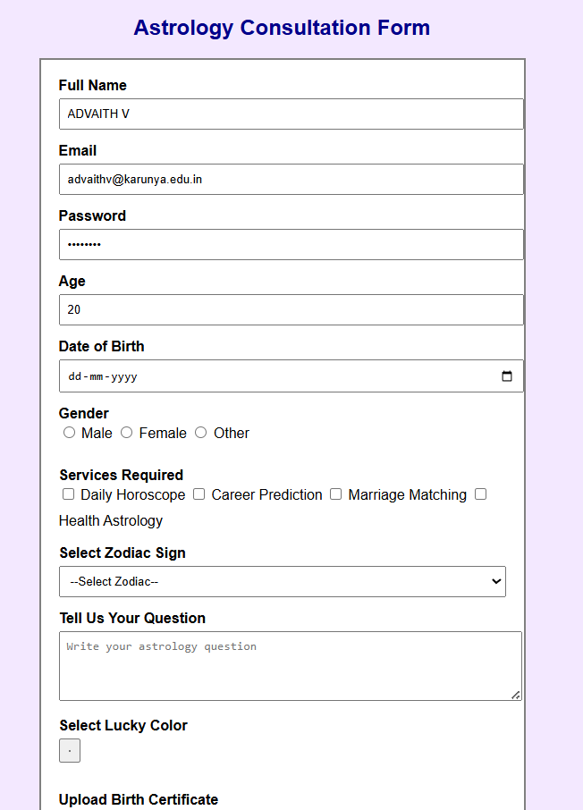

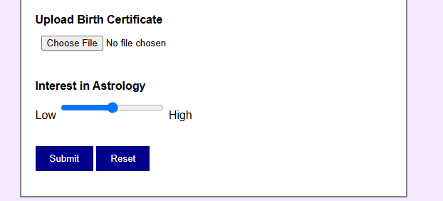

Result
Thus, the HTML5 Student Registration Form was successfully developed using various HTML5
form elements and validation attributes. The browser validated user input without JavaScript,
demonstrating the effectiveness of HTML5 form controls in creating interactive and
user-friendly web applications.

